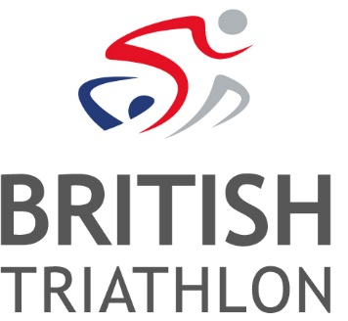
Job Vacancy: Events Intern
Ref: EVE-17-36
Salary: £13,750pa (pro rata) + Pension
Contract: FTC (till end of September 2018), Full time

British Triathlon is the National Governing Body for Triathlon, Duathlon and Aquathlon in Great Britain, responsible for raising the profile and delivering medal-winning performances and helping everyone discover, enjoy and achieve in triathlon.
Triathlon England is one of the three Home Nations of British Triathlon, the other two being Triathlon Scotland and Welsh Triathlon. The three Home Nation Associations are responsible for all aspects of triathlon in their respective countries, and contribute to the work of British Triathlon.
In the glow of Rio and other key successes, British Triathlon’s vision is to continue to grow participation in the sport through the delivery of inspirational event opportunities. Key to this is the British Triathlon Major Events Programme which aims to showcase the sport in a positive spotlight to new and existing audiences.
British Triathlon has an exciting new opportunity for an Events Intern within their Major Events team. The Events Internship is a seasonal position (January 2018 – end of September 2018) to support the British Triathlon Major Events Team through a busy triathlon season of events.
Working with the British Triathlon Events Team the Events Intern will experience a variety of triathlon Championships as well as international events. This is a fantastic opportunity to join the progressive governing body of a fast-growing, modern and dynamic Olympic and Paralympic sport. If you have a passion for sport and are looking for event management experience, then this role is for you.

The role will be based at the British Triathlon headquarters located at Loughborough University; however, the nature of the internship will require evening and weekend working and occasional travel.
Informal enquiries can be made to Megan Cornick, Event Coordinator
email: megancornick@britishtriathlon.org
To apply:
Please visit www.britishtriathlon.org/about/vacancies for our application form, job description and equality form. A covering letter explaining why you feel you are suitable for the role, together with your completed application form and equality form, should be e-mailed to: hr@britishtriathlon.org. Please quote the reference number EVE-17-36. Should you require assistance with the application process, please contact HR and we will make every effort to meet your specific requirements.
Closing Date: 12noon Thursday 4 January 2018
Interview Date: Friday 12 January 2018

British Triathlon is committed to equality of opportunity for all staff and applications from all suitably qualified persons are encouraged. Details of our Equal Opportunities Policy can be found on our website: www.britishtriathlon.org under ‘About’ and then ‘Policy Documents’.

