Triathlon England – East Region

ANNUAL GENERAL MEETING
Novotel Hotel - Stansted
Wednesday 18th October 2017 – 7.30 p.m.

AGM Minutes
Attendees:
Elisabeth Ross-Tri-Sport Epping, Kevin Carley-Blackwater Tri, Sue Fuller-East Essex Tri, Clive Hatch-Blackwater Tri, Ian George-East Essex Tri, Trevor Lunnon-Meridian Tri, Mark Wilsher-Meridian Tri, Stephen Douglas-Meridian Tri, Liz Heselwood-Monster Racing, Dani Hill-Welter-Stortford Tri, Elaine Bramley-Walden Tri, Noel Bely-Walden Junior Tri, Benoit Bely-Walden Junior Tri, Charlotte Smith-Thetford AC, Jane Campbell-Kings Lynn Tri Club, Sam Vail-Cambridge Tri, Sally Vail, Cambridge Tri, Sasha Vail, Cambridge Tri, Charlotte Gowers-Infinity Tri, Jo Gowers-Infinity Tri, Ian Gowers-Infinity Tri, Simon Gowers-TriSudbury, Mark Philo-Tri-Anglia, Chris Price-Hoddesdon Tri, Colin Bradley-LB Tri, Amy Armstrong-LB Tri, Tyusha Preston, Rav Dighe-Aloha Tri, Peter Pain-British Triathlon, Rob Lines-British Triathlon, Richard Fuller-East Essex Tri, Jonathan Davies-Born2Tri, Laura Brown-West Suffolk Wheelers, Giles Prime-West Suffolk Wheelers, Dave Bennett, Liz Bennett-Cambridge Tri.
Welcome to Attendees
Richard Fuller welcomed the attendees to the meeting and explained that Jonathan Davies the interim chairman is covering for the Secretary and gave an overview of his role in the region on the TE Council and Board.
Apologies for Absence
Ursula Adeane, Peter Bryan, Kate Liddiard, Ashley Nicholson
Minutes of last Meeting - October 2016 AGM
These were reviewed and agreed: proposed Elisabeth Ross, seconded Kevin Carley
Election of Committee and TE Council Member
Richard Fuller explained the roles which are currently vacant and requested a volunteer to stand for the chair role, there were no volunteers and Jonathan Davies was invited to be interim chair until a new volunteer can be found. Elisabeth Ross was elected as Treasurer, Kate Liddiard was elected as Secretary, Clive Hatch was elected to Committee all unopposed and Jonathan Davies was elected as TE Council representative unopposed.
Chairman’s and Technical Coordinator’s Report
2017 has been a year of a loss, a huge gain, a loss and a loss to come.
Let me explain, in January our long serving regional manager, Carol Macdonald decided to leave British Triathlon and head to warmer climes in Spain. For the life of me I can’t think why! Carol leaving left a huge hole in terms of supporting our sport in the region and we knew as a committee that it would be difficult to find someone with the knowledge of the sport and skills to take on the role and continue the legacy Carol left behind. Interviews were held and no one was appointed, as a committee we waited with baited breath.
In the meantime, our regional Chairman Rob Lines was doing a great job providing leadership for our sport in the region and not even being abroad stopped him from chairing committee meetings which he did via Skype. Now there’s commitment for you. I think everyone was surprised when Rob announced that he had been appointed to take over from Carol and I don’t think anyone could think of anyone better qualified or more committed to do so. If a region can breathe a sigh of relief we did in April (I think) when Rob took over. This was the huge gain. Of course, having become a permanent member of BTF staff Rob could no longer chair the region and so this was the second loss but on balance this is one loss I think everyone is happy to see. As the previous incumbent I volunteered to take on the chairman role until a new volunteer could be found.
The loss to come is the news that Richard Fuller had decided to go travelling and is stepping away from his pivotal and stalwart role in the region. To put this into context Richard is our TE Council Member, Board Member for East and South-East Region, Regional Treasurer, past Chairman and brains behind the Regional Relays for many years. In addition, he is a race organiser, active member of East Essex Tri as well as being a committee member there to and he also somehow finds time to race as a GB age grouper. During my time on Committee as both Regional Technical Coordinator and Chairman I have relied on Richard’s counsel, calm approach and I will miss the deep breath before he says, ‘well Jonathan’………. To say Richard is leaving a massive hole in the region and our sport is probably the understatement of the Century and I and the committee will miss him tremendously.
Now on to my Technical Coordinator’s Report
This year we have seen 108 races taking place in the region, with 93 of those requesting a Technical Official representing something like 650 hours of volunteering from a small group of dedicated officials. We have had national championships and qualifiers where East TOs have shown the rest of the country just how we do things all the way down to small events with less than thirty competitors. To qualify as a Local Technical Official requires around 36 hours of study and practice but the rewards of seeing races as safe and fair make it all worthwhile. As with most years we have welcomed another four LTOs to the officiating community and we have said goodbye to two of our most experienced National Technical Officials in Dawn Vaughan and Peter Bryan, we wish them well for the future and it is right that I recognise the time, skill and energy they put in to being part of the TO community.
To recognise the work our TOs do we held our first annual conference in January where we were privileged to have the TE Director of Rules, Technical and Events, Duncan Hough give a presentation about his work on the international officiating stage and being part of the officiating team at Rio 2106. We also have the East TOs Facebook group which sees a good exchange of ideas and questions from the newest to the most experienced officials. We are one of the few regions to have an annual conference and the only one with its own dedicated Facebook group which highlights the standards we work to. In addition, our competency test for the final race shadow for LTOs was recognised by the BTF as an example of good practice and this reinforces the high level of expected competency we achieve in the region.
The region’s TOs also recognise one of their own as the Regional Official of the Year in Dave Bennett who will be receiving his well-deserved award later this evening. I think it is worth however just embarrassing Dave for a minute or two. Dave shone as a technical official right from the local technical official’s course and he has progressed at a steady rate through that course and to qualify as a Regional Technical Official. As TOs we get used to getting up at daft o’clock on Sundays and quite often Saturdays too and putting our ‘happy heads’ on but with Dave his natural humour and upbeat personality make that an awful lot easier. Dave has a great officiating style coupled with good technical knowledge too so is an all-round great official and a very worth winner of the region’s official of the year award. Hope that’s OK Dave and have you booked my flights and hotel in the Bahamas yet?
Finally, I’m pleased to announce that two past winners of the regional official of the year awards, Sam Fielding and Clive Hatch, have been confirmed as attending the next National Technical Officials course in February 2018. It takes a lot of time, effort, travel, skill and having the right approach to working as part of a team just to even be considered. If you think becoming a level 3 coach is hard then that has nothing on becoming a National Technical Official.
I commend both my reports to the AGM and thank you for your time and indulgence.
Treasurer’s Report
Richard Fuller outlined the region’s financial position and showed the report on screen as follows
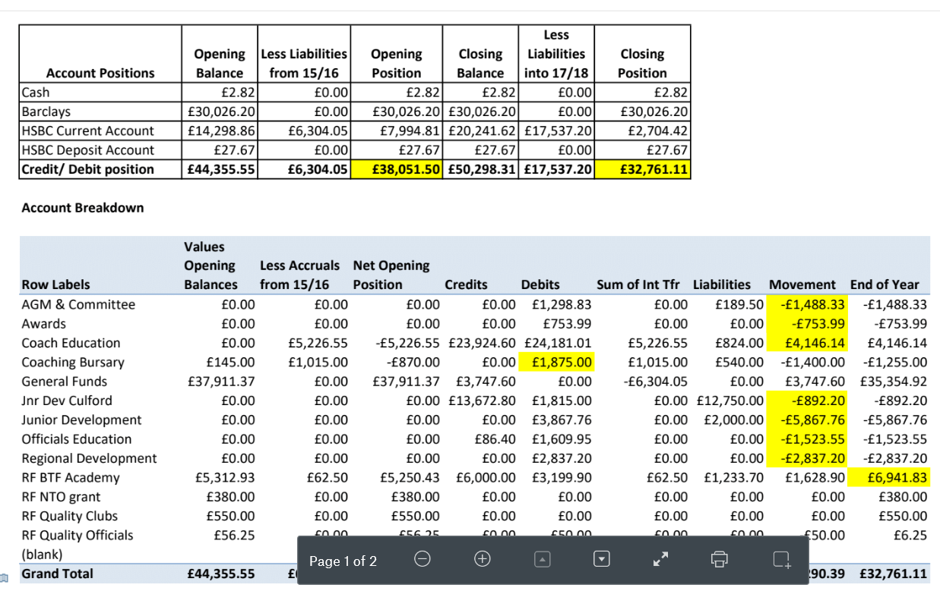
Regional Head Coach’s Report
Tim Williams outlined the achievements of the Regional Academy and the region’s performances at the under 20s festival where we had two individual winners, training camps held, notable successes from individual athletes and noted that the Regional Academy has been fully self-sufficient from funding by the Region. Tim outlined some of the changes happening the Regional Academy and in particular from the BTF performance programme with less formal tools to try and help young athletes develop in different areas in a less formal structure.

Skills School Update by Emma Springham
Emma presented a series of slides about the work of the Skills School in the region and how it will be developing from the strong base built so far.
Regional Manager Report
Rob Lines outlined his work for the year and introduced Peter Pain the national manager for the BTF. Rob mentioned about the funding for the region and mentioned the two big events for the sport this year in the mixed relay cup and WTS Leeds. Rob gave information about national membership and mentioned that membership is up and churn rate is down, flyers were left on each table to encourage club members who are not members of Triathlon England to join. Rob mentioned the partnership with RLSS for open water safety and the launch of the Tri-Mark club accreditation and the need for junior and children’s clubs to be registered within 12 months. As a region there are around 2400 TE members, 72 clubs, held a number of Go Tri’s, GO Tri activities to help people get ready for their first triathlon and gym members to take part in the sport. Two level 1 and one level 2 coaching courses, a LTO and a RTO course were held. In terms of clubs and members there are a number of TE members in Colchester but no club to help them so this is a key priority for the next committee year.
Constitution Changes for 2017

Richard Fuller identified the changes to the regional constitution as:

- Standardising the name of the region as Triathlon England East Region
- Recognising that the region uses internet banking
- Standardising the region’s financial year
- Recognising the rights of LGBT members and the constitution now requires best endeavours to ensure a minimum of 25% of committee members to be people who identify themselves as female and 25% who identify themselves as male.

Richard also mentioned the Triathlon England AGM and the regional award winners going forward for judging for national awards.

Triathlon England constitution 2017/18
Richard Fuller outlined the changes to the TE constitution which will be discussed at the AGM mentioned above and recommended that the motion be carried for the region to ensure funding continued.
AOB

There being no other business the meeting closed at 20.33.

